**A Differential Protection Scheme for Tapped Transmission Line Containing UPFC and Wind Farm**

*A report submitted in partial fulfillment of the requirements for the Award of Degree of*

**Bachelor of Technology**

**In**

**Electrical Engineering**

Submitted By:

K Chandu Naidu (1901106103)

Arnit Panda (1901106271)

Durgadutta Das (1901106296)

Under the Guidance of:

**Prof.(Dr.) Lokanath Tripathy**

**Professor, Electrical Engineering Department**



**(ବୈଦ୍ୟୁତିକ ଯାନ୍ତ୍ରିକ ବିଭାଗ)**

**DEPARTMENT OF ELECTRICAL ENGINEERING**

**ଓଡ଼ିଶା ବୈଷୟିକ ଓ ଗବେଷଣା ବିଶ୍ବବିଦ୍ୟାଳୟ**

**ODISHA UNIVERSITY OF TECHNOLOGY AND RESEARCH, BHUBANESWAR-751029**

**@2023**

ଓଡ଼ିଶା ବୈଷୟିକ ଓ ଗବେଷଣା ବିଶ୍ବବିଦ୍ୟାଳୟ

ODISHA UNIVERSITY OF TECHNOLOGY AND RESEARCH

(Formerly College of Engineering & Technology)

Ghatikia, Bhubaneswar-751029

Department of Electrical Engineering (EE)

**(ବୈଦ୍ୟୁତିକ ଯାନ୍ତ୍ରିକ ବିଭାଗ)**

**---------------------------------------------------------------------------------------------------------------------------**



**CERTIFICATE**

This is to certify that the project report entitled “**A Differential Protection Scheme for Tapped Transmission line Containing UPFC and Wind Farm**” submitted by *K Chandu Naidu (Registration No. 1901106103), Arnit Panda (Registration No. 1901106271), Durgadutta Das (Registration No. 1901106296)* of the Department of Electrical Engineering, fulfils the requirement of the regulation relating to the nature and standard of the work for the award of the degree of Bachelor of Technology, in Electrical Engineering for academic year 2022-23.

Prof. (Dr) Ajit Kumar Barisal Dr. Lokanath Tripathy

**HOD, Electrical Engineering Department Supervisor**

**External Examiner**

ଓଡ଼ିଶା ବୈଷୟିକ ଓ ଗବେଷଣା ବିଶ୍ବବିଦ୍ୟାଳୟ

ODISHA UNIVERSITY OF TECHNOLOGY AND RESEARCH

(Formerly College of Engineering & Technology)

Ghatikia, Bhubaneswar-751029

Department of Electrical Engineering (EE)

**(ବୈଦ୍ୟୁତିକ ଯାନ୍ତ୍ରିକ ବିଭାଗ)**

**---------------------------------------------------------------------------------------------------------------------------**



**DECLARATION**

We do hereby declare that the major project entitled, “**A Differential Protection Scheme for Tapped Transmission line Containing UPFC and Wind Farm**” is a bona-fide work of study carried out by us under the guidance of *Dr. Lokanath Tripathy, Professor,* Department of Electrical Engineering, Odisha University of Technology and Research, Bhubaneswar. It has been prepared for the fulfilment of the requirements of the degree of ‘Bachelor of Technology in Electrical Engineering’. The work has not been submitted for any other purpose.

PLACE: Bhubaneswar K Chandu Naidu (1901106103)

DATE: Arnit Panda (1901106271)

Durgadutta Das (1901106296)

**ACKNOWLEDGEMENT**

We would like to express our deepest gratitude to all those who have contributed to the successful completion of this major project. Without their support, this project would not have been possible.

Firstly, we would like to thank our supervisor Dr. Lokanath Tripathy for his constant guidance and support throughout the project. His valuable feedback, suggestions, and advice have been instrumental in shaping the direction of this project and ensuring its successful completion.

We additionally give thanks for his perceptive comments and suggestions that regularly helped to boost our understanding and knowledge.

Also, my profound gratitude goes to the Head of the Department of Electrical Engineering Dr. Ajit Kumar Barisal, who patiently saw me to the completion of this research work.

We would also like to thank all the university members within the department who provided us with valuable insights, expertise, and advice. Their contributions have been vital in ensuring the quality and relevance of the project.

Finally, we would like to acknowledge the support of our families and friends who have given moral support throughout this project work and provided motivation and encouragement for completion of this project. Above all, we give thanks to almighty who bestowed blessings upon us.

K Chandu Naidu (1901106103)

Arnit Panda (1901106271)

Durgadutta Das (1901106296)

**ABSTRACT**

This work proposes a novel protective strategy for a transmission line connecting to a Wind Farm and Unified Power Flow Controller (UPFC) that has been tapped. This practical and efficient protection strategy was framed by combining the robust analysing and decomposing capabilities of Wavelet Transform (WT) with the precise phasor extraction capabilities of Discrete Fourier Transform (DFT). The main goal of the suggested plan is to use Wavelet Transform to extract third level decomposed current signals from each substation. After extracting the appropriate fundamental phasors using DFT, third level approximate coefficients (CA3) will be reconfigured for each line current at each substation to obtain operating and restraining quantities. On MATLAB environment, the proposed scheme was tested on a 500 kV, teed transmission line with UPFC and a wind farm (as one of the substations) in the presence of various fault and operating situations. The feasibility of the suggested relaying strategy is demonstrated in this major project. The results of simulating various faults at various transmission line locations is compared in order to assess the effectiveness of the proposed differential relaying scheme in comparison to the conventional relaying scheme.

**LIST OF ABBREVIATIONS**

|  |  |
| --- | --- |
| DWT | Discrete Wavelet Transform |
| DFT  WT  CWT | Discrete Fourier Transform  Wavelet Transform  Continuous Wavelet Transform |
| UPFC | Unified Power Flow Controller |
| CT | Current Transformer |
| CB | Circuit Breaker |
| OC | Over Current |
| STATCOM | Static Synchronous Compensator |
| SSSC | Static Series Compensator |
| FACTS | Flexible Alternating Current Transmission System |
| AT | Ampere Turns |
| VSC | Voltage Source Converter |
| DFIG | Doubly-Fed Induction Generator |
| RTDS | Real Time Digital Simulator |
| DSP | Digital Signal Processing |
| PWM | Pulse-Width Modulation |
| Eop or Eopf | Operating Signal |
| Eres | Restraining Signal |

**LIST OF TABLES**

|  |  |  |  |
| --- | --- | --- | --- |
| **Chapter No.** | **Table No.** | **Table Caption** | **Page No.** |
| 1 | 1.1 | Literature Review | 2 |
| 4 | 4.1 | Parameters used in the System | 21 |

**LIST OF FIGURES**

|  |  |  |  |
| --- | --- | --- | --- |
| **Chapter No.** | **Figure No.** | **Figure Caption** | **Page No.** |
| 2 | 2.1 | Simple differential protection scheme behaviour under normal condition. | 4 |
| 2 | 2.2 | Simple differential relay, internal fault and external fault characteristics | 5 |
| 2 | 2.3 | Percentage (biased) differential relay | 6 |
| 2 | 2.4 | Percentage differential relay, internal fault and external fault characteristics | 8 |
| 2 | 2.5 | Unified Power Flow Controller (UPFC) | 9 |
| 2 | 2.6 | Equivalent Voltage Representation of UPFC | 9 |
| 2 | 2.7 | Static Synchronous Compensator (STATCOM) | 10 |
| 2 | 2.8 | Static Synchronous Series Compensator (SSSC) | 12 |
| 2 | 2.9 | Basic two machine system with SSSC | 12 |
| 2 | 2.10 | Typical back-to-back arrangement of inverter and converter circuits to control power flow. | 14 |
| 2 | 2.11 | Three Level Wavelet Decomposition Tree | 16 |
| 3 | 3.1 | Proposed Relaying Scheme | 17 |
| 4 | 4.1 | Schematic Diagram of Teed Transmission System | 19 |
| 4 | 4.2 | Simulation Diagram | 19 |
| 5 | 5.1 | Magnitude and Phase Angle of A-phase current for A-G fault at a distance 100k.m from substation-1 | 23 |
| 5 | 5.2 | Magnitude of different phase currents for A-G fault at a distance 100k.m from substation-1 | 23 |
| 5 | 5.3 | E­opf and Eres for A-G fault at a distance 100k.m from substation-1 | 24 |
| 5 | 5.4 | Effect of fault inception angle for internal A-G fault at a distance 100k.m from substation-1 | 24 |
| 5 | 5.5 | Effect of External A-G fault at far-end of substation-3 on Eop and Eres | 25 |
| 5 | 5.6 | Effect of fault resistance on Eop and Eres for internal A-G fault at a distance 100k.m from substation-1 | 26 |
| 5 | 5.7 | Effect of different wind speed on Eop and Eres for internal A-G fault at a distance 100k.m from substation-1 | 26 |
| 5 | 5.8 | Effect of Reverse Power Flow with internal A-G fault at far-end of substation-2 on Eop and Eres | 27 |

**TABLE OF CONTENT**

|  |  |
| --- | --- |
| **Title** | **Page No** |
| CERTIFICATE | i |
| DECLARATION | ii |
| ACKNOWLEDGEMENT | iii |
| ABSTRACT | iv |
| LIST OF ABBREVIATIONS | v |
| LIST OF TABLES | vi |
| LIST OF FIGURES | vii |
|  |  |
| CHAPTER 1: INTRODUCTION |  |
| 1.1: Overview | 01 |
| 1.2: Literature Review  1.3: Problem statement | 02 |
|  |  |
| CHAPTER 2: THEORY |  |
| 2.1: Differential Protection  2.2: Unified Power Flow Controller (UPFC)  2.3: DFIG Wind Turbine | 03  09  13 |
| 2.4: Signal Processing | 14 |
| CHAPTER 3: PROPOSED METHOD  3.1: Case Study and Test Result | 17 |
|  |  |
| CHAPTER 4: MODELS (SIMULATION)  4.1: Schematic Diagram  4.2: Simulink Model  4.1: Parameters of the desired System  4.2: Different Cases Investigated | 19  19  20  21 |
| CHAPTER 5: RESULT ANALYSIS  Different Case Studies | 22 |
| CHAPTER 6: CONCUSION |  |
| 6.1: Conclusion | 28 |
| 6.2: Future Scope | 28 |
|  |  |
| REFERENCES | 29 |

**Chapter 1**

**INTRODUCTION**

* 1. **Overview**

Protection, transient stability, and voltage stability are the main factors limiting power transfer in the majority of integrated transmission systems. These restrictions prevent transmission corridors from being used to their full capacity. FACTS is a technology that offers the necessary transmission functionality modifications to fully utilize the transmission systems that already exist and, as a result, reduce the distance between the stability and temperature limitations.

The major element is the accessibility of electrical switching equipment that can switch electricity at megawatt levels (kV and kA levels). Therefore, it is probable that the effects of FACTS controllers on transmission systems will have a substantial impact on power system networks globally (especially with regard to the protection issues). The voltage and current signals at the relay point will be adversely affected in both the steady state and transient state due to the presence of FACTS controllers in a fault loop.

Thus, the effectiveness of current protective plans will be reduced. Unified Power Flow Controller (UPFC), the most significant FACTS device among all of them, is widely utilised to increase the efficiency of the current transmission system. With the ability to independently manage three crucial power system characteristics, such as bus voltage, line active power, and line reactive power, the UPFC opens up new possibilities in terms of power system control. While the introduction of UPFC increases a power system's ability to transfer power and stability, other issues with power system protection, specifically the protection of transmission lines, arise that have a significant impact on the distance relay's range.

* 1. **Literature Review**

|  |  |  |  |  |
| --- | --- | --- | --- | --- |
| **Sl. No.** | **Name of the Paper** | **Authors** | **Publication** | **Content Derived** |
| 1 | A Differential Protection scheme for Tapped Transmission Line containing UPFC and Wind Farm | L. N. Tripathy, M. K. Jena, S. R. Samataray and Satyabadi Mishra | International Journal of Electrical Power & Energy Systems, Nov. 2014 | Introducing a new differential relaying scheme based on transient energy using DWT in current signals |
| 2 | Understanding FACTS Concepts and Technology of Flexible AC Transmission Systems | N. G. Hingorani and L. Gyugyi | New York: IEEE Press, 2000 | FACTS concepts and different components of UPFC and their working principle |
| 3 | An Approach Using Wavelet Transform for Fault Type Identification in Digital Relaying | P.M. Silveira, R. Seara, and H.H. Zurn | IEEE-PES Summer Meeting, Vol. 2, pp. 937 –942, 1999 | Use of wavelet transform in power transmission lines for identifying fault types through wavelet filters |

**Table 1.1 Literature Review**

* 1. **Problem Statement**

Transmission lines with many terminals and taps are more widespread these days due to the expansion of the power system. Different teed designs, however, provide unique issues and pose additional threats to the transmission line protection. Therefore, the problem of preserving that specific transmission system becomes much more difficult when we combine all these complications into one system composed of UPFC and wind farms connected by a teed line. A distinct relaying approach for this kind of transmission system is therefore strongly motivated.

**Chapter 2**

**THEORY**

* 1. **Differential Protection**
     1. **Introduction**

Differential protection is an effective protection method that identifies internal faults in electrical equipment by contrasting the electrical circumstances at the terminals of the equipment. This method is highly sensitive and can detect even the smallest differential currents. However, it has a limitation as it necessitates currents from the ends of a protection zone, which restricts its use to large-scale electrical equipment like generators, transformers, and motors, among others. Since it is restricted to the protection of a specific unit or equipment, such as a bus zone, reactor, or capacitor, it is referred to as unit protection.

To safeguard electrical equipment against internal faults, differential protection is a useful approach that compares the electrical conditions at the equipment's terminals. It is an effective and sensitive protection method that can detect even tiny differential currents. Nevertheless, it has a drawback as it necessitates the use of currents from the edges of a protection zone, making it appropriate only for the safeguarding of large electrical equipment such as generators, transformers, and motors. Differential protection, often referred to as unit protection, is limited to safeguarding a particular unit or equipment, such as a bus zone, reactor, or capacitor.

The central element of a protection system that differentiates is the differential relay, which activates at the time when the difference in phasors between two or more similar electrical properties goes beyond a predetermined threshold. Current differential type relays are typically used. Current transformers (CTs) are positioned on either side of each coil in the machine, and the relay coils receive the outputs from their secondary coils.

* + 1. **Differential Relays**

A differential relay functions as an overcurrent relay that is correctly linked and triggers when the difference in phasors between currents at both ends of a safeguarded component goes beyond a pre-established limit. The majority of differential relays are of the current differential variety.

The following are the various types of differential relays.

1. Simple (basic) differential relay
2. Percentage (biased) differential relay
3. Balanced (opposed) voltage differential relay
   * 1. **Simple (basic) Differential Relay**

The term "basic differential relay" is also used to refer to a simple differential relay. A simple differential relay is an overcurrent relay with an operating coil that measures the divergence in phasors between currents at both ends of a safeguarded component. The overcurrent relay triggers when the phasor difference between the secondary currents of the CTs at both ends of the protected component exceeds a predetermined threshold. A pilot-wire circuit connects the secondary coils of the CTs at both ends of the protected component, and the operating coil of the overcurrent relay is linked in the center of the pilot wires. The protective system that uses a simple differential relay is referred to as either "simple differential protection" or "basic differential protection".

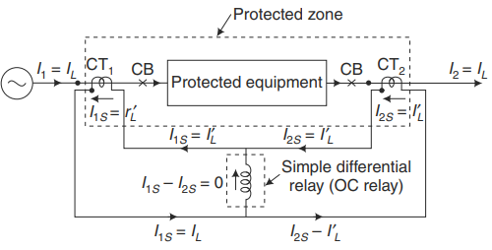

**Fig 2.1: Simple differential protection scheme behaviour under normal condition.**

**(*I1* = *I2* = *IL* and *I1S* = *I2S* = *IL*, hence *I1S* – *I2S* = 0)**

where, CT1, CT2 = Current Transformers

CB = Circuit Breakers

*I1* = Input Line Current, *I2* = Output Line Current

*I1s*= Secondary current in CT1, *I2s* = Secondary current in CT2

* + 1. **Disadvantages of Simple Differential Protection Scheme**

In practice, it is difficult to get ideal, identical, and exactly matched CTs. CTs used in practice will not always give the same secondary current for the same primary current, even if they are commercially identical, i.e., of the same rating and manufactured by the same manufacturer. The difference in secondary current, even under normal conditions, is caused by constructional errors and CT errors (ratio and phase angle errors). CT errors depend upon the saturation characteristics of CTs and CT burdens which in turn depend on the lengths of the pilot wires (cables) and the impedance of the relay coil.

* + 1. **Characteristics of Simple Differential Protection Scheme**

The function of the differential relay is to respond solely to an internal fault and not activate during normal power flow or external fault situations. The magnitude and location of a fault current, along with variations in the source impedance, can impact both internal and external faults. The fault current will be maximum under the following conditions:

* The fault is symmetrical three phase fault.
* The fault is close to the transformer terminals.
* The source impedance is minimum.

The fault current will be minimum under the following conditions:

* The fault is single line-to-ground (L–G) fault.
* The L–G fault is close to the grounded neutral.
* The source impedance is maximum.

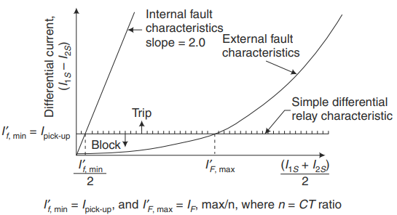

**Fig 2.2: Simple differential relay, internal fault and external fault characteristics**

The overcurrent relay measures the difference between the currents flowing through *I1s* and *I2s*, while the average of these currents flows through the pilot wire. If the magnitudes of *I1s* and *I2s* are not equal, the difference current flowing through the relay is non-zero. If this difference current exceeds the relay's pick-up current, it triggers a signal to the circuit breaker, causing it to isolate the equipment from the main circuit. Theoretically, this relay should only activate in the case of an internal fault and not for external faults. However, there may be practical errors due to variations in the secondary current of CTs used in practice, even if they are identical in rating and manufactured by the same company.

* + 1. **Percentage or Biased Differential Relay**

One way to address the issue of a simple differential relay malfunctioning due to current transformer (CT) errors during heavy external faults is by utilizing a percentage differential relay. This type of relay provides increased sensitivity to minor internal faults, while also providing strong security measures to prevent malfunction during external faults. As a result, the implementation of a percentage differential relay can improve the stability of a differential protection system.

This particular relay consists of two coils: one is referred to as the restraining coil and it hinders the tripping of the relay, while the other one referred as operating coil generates the necessary torque for relay activation. The relay operates only when the operating torque exceeds the restraining torque. The midpoint of the restraining coil is connected to the operating coil, with *Nr* and *N0* representing the total number of turns in the restraining and operating coils, respectively.

The restraining coil is tapped at the center and divided into two equal sections with *Nr*/2 turns each. This coil is incorporated into the circulating current path so that current *I1s* flows in one part of the coil and *I2s* flows through int the other part, and the entire restraining coil, consisting of *Nr* turns, carries the through fault current of (*I1s* + *I2s*)/2. The operating coil, which consists of *N0* turns, is positioned in the spill path, so that (*I1s* – *I2s*) the differential current flows through it.

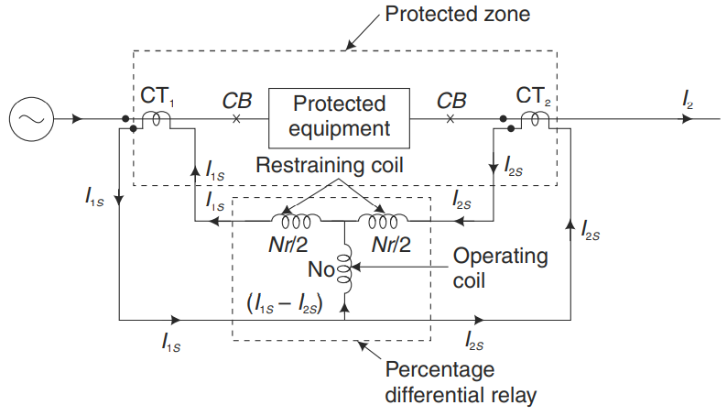

**Fig 2.3: Percentage (biased) differential relay**

The relay will only function when the torque generated by the operating coil exceeds the torque produced by the restraining coil. Since torque is directly related to the number of ampere-turns, the relay will activate when the ampere-turns in the operating coil (AT)0 are higher than those in the restraining coil (AT)r.

Ampere-turns of the left-hand section of the restraining coil =

Ampere-turns of the right-hand section of the restraining coil =

Total ampere-turns of the restraining coil, (AT)r = =

Thus, it can be assumed that the entire *Nr* turns of the restraining coil carries a current

(*I1s* + *I2s*)/2. The current (*I1s* + *I2s*)/2 which is the average of the secondary currents of the two CTs (CT1 and CT2) is known as the ‘through current’ or restraining current, *Ir*. Hence

*Ir* = (*I1s* + *I2s*)/2

The ampere-turns of the operating coil, (AT )0 = N0(*I1s* – *I2s*)

Neglecting spring restraint, the relay will operate when,

or

or

or *Id* *KIr*

where, *Id* = (*I1s* – *I2s*) is the differential current through the operating coil.

*Ir* = (*I1s* + *I2s*)/2 is the restraining current or through current,

and *K* = = Slope or Bias *K* (generally expressed as a percentage value)

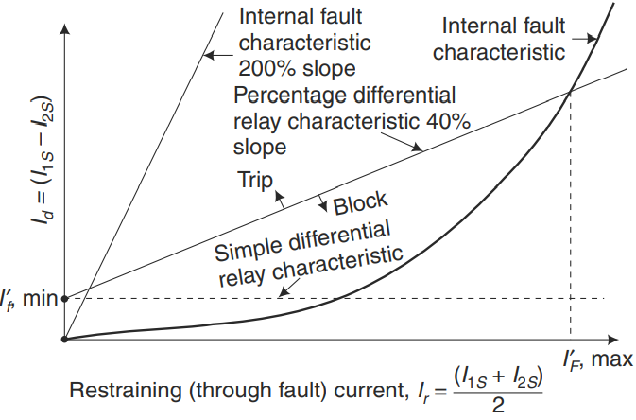

**Fig 2.4: Percentage differential relay, internal fault and external fault characteristics**

* + 1. **Stability Ratio**

In Figure 2.2, the stability ratio (S) for a differential protection system can be calculated as the ratio of the highest current that can cause the relay to malfunction () to the lowest internal fault current that the relay can detect and operate correctly ().

Stability ratio (*S*) = (1)

where, = Maximum external (through) fault current within which the relay will not maloperate, and beyond which the relay will maloperate.

= Minimum internal fault current for which the relay will correctly operate, if fault current is less the relay will not operate.

Ideally, the stability ratio should be maximized within the limits of the design. Typically, desired values range from 100 to 300. However, the stability ratio is usually quite low for a basic differential relay, which is why a biased or percentage differential relay has been developed.

* 1. **Unified Power Flow Controller (UPFC)**
     1. **Introduction**

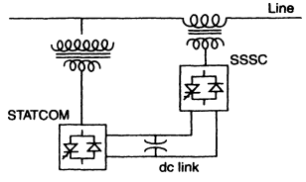The UPFC consist of two FACTS devices, namely the STATCOM and the SSSC, which are connected together by a DC link. Real power can be bidirectionally transmitted between the SSSC and the STATCOM. The UPFC can provide both real and reactive compensation to the transmission line simultaneously without requiring an extra energy source to connect externally. The UPFC has the ability to manage the voltage, impedance, and angle of the transmission line, along with controlling the real and reactive power flow in the line, by injecting series voltage without angular constraint. Furthermore, the UPFC can also provide independent control of shunt reactive compensation.

**Fig 2.5: Unified Power Flow Controller (UPFC)**

* + 1. **UPFC Model**

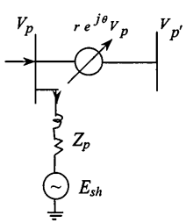A dc storage capacitor provides the shared dc link for two switching converters that make up the UPFC. Converter 2 is primarily responsible for injecting an AC voltage into the transmission line in series, using a series transformer 1, thus performing the primary function of the UPFC. Converter 1's fundamental purpose is to provide or absorb the real power demand created by Converter 2 at the shared dc link. Balancing of power between the series and shunt converters determines the active component of the current of Converter 1, The reactive element can be modified separately as needed to provide voltage assistance at the bus.

**Fig 2.6: Equivalent Voltage Representation of UPFC**

Fig. 2.5 shows the schematic representation. In Fig. 2.6, the source models are shown from which we obtain



(6)

The magnitude |*V*| is controllable by UPFC and the angle θ is controllable from 0 to 2π. The shunt current is obtained as

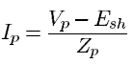

(7)

where *Esh* is the shunt converter voltage controlled by the UPFC and *Zp* being its impedance.

* + 1. **Shunt Connected Controllers**

**Static Synchronous Compensator (STATCOM):**

STATCOM is considered a significant FACTS Controller Figure 2.7 depicts a basic one-line diagram of a STATCOM that uses a voltage-sourced converter. In terms of cost, voltage-sourced converters are generally preferred. With a voltage-sourced converter, the output voltage is regulated to provide the necessary reactive current flow for any AC bus voltage, and the voltage across capacitor is adjusted automatically to act as the converter's voltage source.

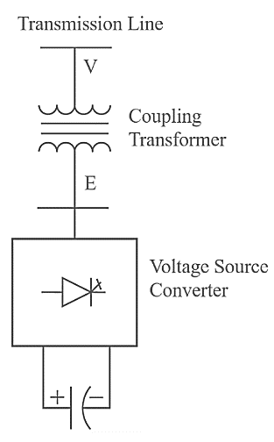

**Fig 2.7: Static Synchronous**

**Compensator (STATCOM)**

**Working Principle of STATCOM:**

In order to comprehend how STATCOM operates, we must initially examine the equation governing the transfer of reactive power. The setup displayed in the diagram involves the connection of two sources, *V1* and *V2*, with an impedance *Z = Ra + jX*.[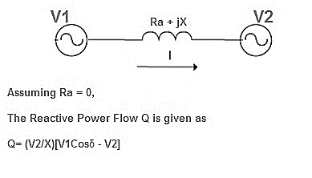](https://1.bp.blogspot.com/-5JA8Xt2Stq0/WDmWu_IfcwI/AAAAAAAACcs/iJAZB55kWdUe4phdzmLjCHsVHe1HC1gIgCEw/s1600/power+flow+equation.jpg)

Assuming *Ra = 0*, The reactive power flow *Q* is given as



(8)

In the reactive power flow equation, angle *δ* is the angle between *V1* and *V2*. Thus, if we maintain angle *δ* = 0 then Reactive power flow will become



(9)

The active power flow will become



(10)

To summarize, we can say that if the angle between *V1* and *V2* is zero, the flow of active power becomes zero and the flow of reactive power depends on (*V1* – *V2*).

Thus, for flow of reactive power there are two possibilities.

* If the magnitude of *V1* is more than *V2*, then reactive power will flow from source *V1* to *V2*.
* If the magnitude of *V2* is more than *V1*, reactive power will flow from source *V2* to *V1*.

This principle is used in STATCOM for reactive power control.

* + 1. **Series Connected Controllers**

**Static Synchronous Series Compensator (SSSC):** The SSSC functions as a series compensator and doesn't require an external energy source. Its output voltage is at a right angle with the line current and can be adjusted. To improve the power system's dynamic performance, the SSSC may have energy storage or energy-absorbing devices with transient ratings, allowing for temporary compensation of real power to briefly modify the overall resistive voltage drops across the line.

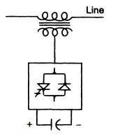

**Fig 2.8: Static Synchronous Series Compensator (SSSC)**

The SSSC is a vital FACTS controller and resembles a STATCOM, but the difference is that it is connected in series with the line. Typically, the injected voltage in series is much smaller than the line voltage. To avoid electrical risks, there is also high insulation to the earth. The converter equipment can be placed at ground level or on an insulated platform by properly insulating the primary and secondary of the transformer. The winding ratio is adjusted to achieve the most cost-effective design of the converter. The SSSC injects a variable voltage, leading or lagging the current by a right angle, without an additional energy source. During severe line faults, the converter must be temporarily bypassed, or else it will have to carry the full line current, including the fault current, in the primary and secondary of the transformer.

**Working of SSSC:**

The SSSC can only absorb or generate reactive power to and from the system when it is connected to a charged capacitor which acts as a source of energy for it. The SSSC works as a series compensator and its output voltage, which is in Quadrature with the line, is controlled. The transmission line's flow of electric power is impacted by the SSSC's changing reactance.

When the SSSC is inductive, the compensating reactance *Xq* has a negative value, while it has a positive value when the SSSC is in capacitive mode. The normalised power flow in the line is impacted by the compensatory reactance. Real and reactive power flow both drop when the emulated reactance is inductive, and the effective reactance rises when the reactive compensation rises in the opposite way. The real and reactive power flow rises when the emulated reactance is capacitive, on the other hand, and the effective reactance falls as the reactive compensation rises in the positive direction. While the phase angle is kept at a right angle to the line current, the magnitude of the inserted voltage is totally controlled.

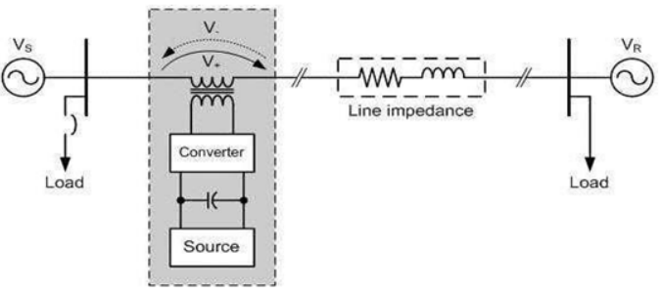

**Fig 2.9: Basic two machine system with SSSC**

* Voltage source converter (VSC)-main component
* Transformer-Couples the SSSC with transmission line.
* Energy source-provides the voltage across DC capacitor and compensate the device losses.
  1. **DFIG Wind Turbine**

The DFIG is widely used in multi-MW wind turbines due to its exceptional performance capabilities. To optimize aerodynamic efficiency and track the optimum tip-speed ratio, the aerodynamic system must be able to operate over a broad wind speed range. Therefore, it is necessary for the rotor of the generator to function at varying rotational speeds. The DFIG can operate in both sub- and super-synchronous modes. The rotor winding is connected via slip rings to a three-phase converter while the stator circuit is connected to the grid. In cases where variable-speed systems require a small speed range, such as around ±30% of synchronous speed, the DFIG is an adequate choice for achieving optimal performance and exploiting typical wind resources.

To handle the rotor power, the power electronic converters are required to have a substantially lower rating, usually around 30% of the nominal generator power. Consequently, the power losses in the converter are significantly reduced in comparison to a system that requires the converter to handle the entire power. Additionally, this results in a lower system cost due to the use of partially-rated power electronics.

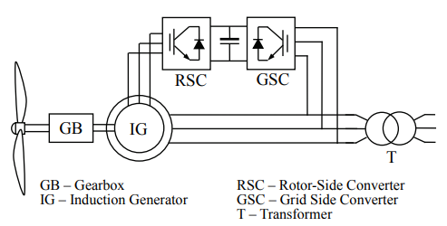

DC Bus

**Fig 2.10: Typical back-to-back arrangement of inverter and converter circuits to control power flow.**

On the rotor of the AC-DC-AC converter, you will find a pair of voltage-sourced converters called the rotor-side converter (RSC) and the grid-side converter (GSC). These converters are interlinked, with a dc-link capacitor placed between them to prevent voltage variations. The RSC is responsible for regulating the torque, speed, and power factor of the DFIG at the stator terminals. Meanwhile, the primary function of the GSC is to maintain a constant dc-link voltage, regardless of the rotor power's magnitude or direction. This converter operates at the grid frequency and is capable of generating or absorbing controllable amounts of reactive power by leading or lagging. You can connect a transformer either between the stator and the grid-side inverter or between the grid and the inverter. The RSC functions at varying frequencies, which depend on the wind speed.

By positioning the converters in a back-to-back configuration, a convenient method is established for converting the generator's ever-changing voltage and frequency output into a stable voltage and frequency output that aligns with the grid's standards. To achieve this, the DC link capacitance serves as an energy reservoir that bridges the gap between the generator and the grid.

* 1. **Signal Processing**

For the investigation of fault transients, the wavelet transform is an effective tool. The discrete wavelet transform (DWT), a specific application of the wavelet transform (WT), is a more effective approach to compute a compact representation of a signal in the time and frequency domain. It provides multi-resolution signal analysis, which analyses the data at various frequencies to provide various resolutions. A long time interval window is accessible when we require more precise low-frequency information, and a short time interval window is available when we require high-frequency information. Instead of using a time frequency zone, it uses a time scale area. A signal is divided into a set of fundamental operations called wavelets via the wavelet transform.

In many digital relay applications, Fourier techniques have traditionally been the principal frequency-domain analysis tool. However, power system fault signals are typically rich in electromagnetic transients, which can pose a challenge for these techniques and others like them. One of the main issues is the width of the window function used in the analysis, which can limit the ability to capture all relevant information in the signal. The length of the signal segment where stationarity is true must match the width of the window utilised in frequency-domain analysis. The moving data window, however, frequently comprises both pre-fault and post-fault samples during transients in the signal. This can lead to unreliable results in the subsequent transform. Although the longer transition period may cause a slower response time, a broader window may offer higher frequency resolution for recording the magnitude of the fundamental frequency. Although its frequency resolution is quite poor, a small window can reduce the downsides of the transition period.

Wavelet transform (WT) has been suggested as a substitute for Fourier techniques in order to solve their drawbacks. A signal is divided into numerous signals by the linear WT operation, each of which has a different scale and time and frequency resolution. This is done by concurrently scaling and translating a single "window" function known as the "mother wavelet." The mother wavelet is an oscillatory function with zero average and rapid decay at both ends, with a compact support.

Wavelets are created via dilations and shifts from a single prototype wavelet known as the mother wavelet.

*CWT* (*b,a*) =

(11)

*Where, a,b(t) =* is the mother wavelet.

*a =* dilation parameter (Scale factor), *b* = translation parameter

Discrete wavelet transform (DWT) transforms a discrete time signal to a discrete wavelet representation. It converts an input series x0, x1, …, xn into one high-pass wavelet coefficient series and one low-pass wavelet coefficient series (of length n/2 each) given by:

Hi =

(12)

Gi =

(13)

where,

*sn*(*Z*) and *tn*(*Z*) are called wavelet filters, k is the length of the filter, and i=0,…, [n/2]-1.

In order to extract features, a wavelet transform is first applied to the current signal of each phase at different substations. The power system transient analysis is an excellent fit for the db4 mother wavelet. To effectively assess the data, a higher sample frequency is needed for the system's 400 km of transmission line (distributed model), UPFC, and wind farm. All computational applications using DWT and DFT in our system are found to be well-suited to the sampling frequency of 20 kHz, or 400 samples per cycle in a 50 Hz system.

In the suggested method, 400 samples are taken each cycle at a sampling frequency of 20 kHz, or 50 Hz. The signal is subjected to three steps of degradation. The frequencies a1 (0-10 kHz) and d1 (10-20 kHz) are used to create level 1, a2 (0-5 kHz) and d2 (5-10 kHz) are used to create level 2, and a3 (0-2.5 kHz) and d3 (2.5-5 kHz) are used to create level 3. Thus, the harmonic components of the current in a3 are its fundamental (50 Hz), third (150 Hz), fifth (250 Hz), and seventh (350 Hz) harmonic components. The third level reconstructed current signal (A3) of each phase is calculated using the estimated coefficient (a3) of the corresponding phases of each substation.

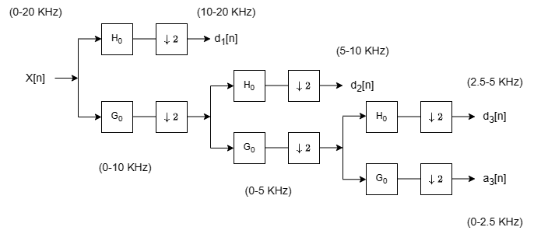

**Fig 2.11: Three Level Wavelet Decomposition Tree**

**Chapter 3**

**PROPOSED METHOD**

* 1. 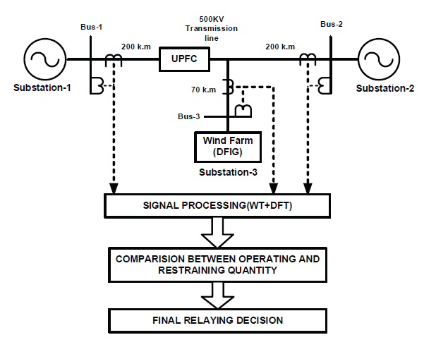**Case Study and Test Result**

**Fig 3.1: Proposed Relaying Scheme**

The design of the suggested relaying scheme is shown in Figure-3.1. Two 500 kV substations with a combined short circuit level of 1500 MVA, a transformer, and a teed transmission line make up the system. A 25 kV facility, the wind farm has a 60 MW (1.5 MW×40) capacity. The signal processing unit receives the current signals from each substation through CT. The third level reconstructed current signal (A3) of each phase at each substation is calculated using DWT utilising the estimated coefficient (a3) of the corresponding phases at each substation. The fundamental current signals' r.m.s values, which were recovered from the current signal (A3) that was rebuilt using DFT, are used to define the operational and restraining quantities for the proposed differential relaying technique. The ultimate relaying decision is then reached after comparing the operating () and restraining quantity ().

The suggested relaying strategy is shown in the diagram above. The r.m.s values of the fundamental current signals for each phase at each substation will be retrieved from the reconstructed current signal (A3) as the rebuilt signals are contaminated with various harmonics in the signal processing step. The differential relay's fundamental operating and restraint currents are then established as follows:

(14)

(15)

where the basic values of the current signals of the a-phase from substations 1 through 3 and 4 are, respectively, , , . The spectral energies of  and  are then used to determine the operational signal (*Eopf*) and restraining signal (*Eref*) using the moving average window of one cycle length, which is given by:

(17)

(16)

Where, N is the number of samples in the sliding window (400 samples per cycle).

By contrasting the operational signal with the restraint one, it is possible to distinguish between internal and external faults as follows:

(19)

(18)

Alarm/Trip Signal

No – operation

Where the scale factor needed to supply the relay with the bare minimum pick-up current is. After a thorough analysis of the parameter and operational state of the system, it is possible to identify the specific value of that is best for a certain circuit.

**Chapter 4**

**MODELS (SIMULATION)**

* 1. 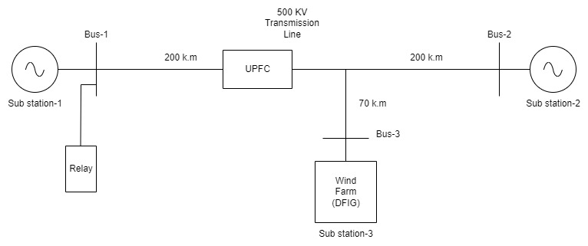**Schematic Diagram**

**Fig 4.2: Schematic Diagram of Teed Transmission System**

A Figure 4.1 displays a power system operating at 500kV and 50Hz. According to the dispersed model, the system consists of three substations and a UPFC that is situated at the middle of the transmission line. Additionally, substation-3 has a wind farm attached to it. The system is made up of three sources, UPFC, and their associated parts as a result.

* 1. 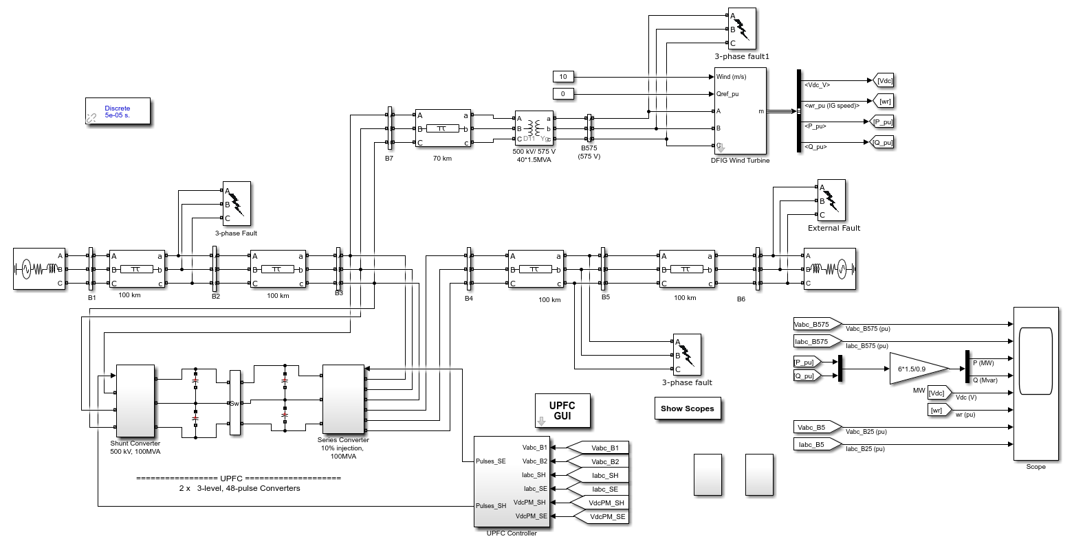**Simulink Model**

**Fig 4.1: Simulation Diagram**

* 1. **Parameters of the desired System**

The transmission line parameters are:

R1=0.01537(Ω/km): Positive sequence resistance

R0=0.04612(Ω/km): Zero sequence resistance

L1=0.8858×10-3(H/km): Positive sequence inductance

L0=2.654×10-3(H/km): Zero sequence inductance

C1=13.06×10-9(F/km): Positive sequence capacitance

C0=4.355×10-9(F/km): Zero sequence capacitance

V1=500kV∠ (Substation-1)

V2=500kV∠ (Substation-2)

V3=500kV∠ (Substation-3)

The 400km long transmission line has a 100-MVA UPFC installed 200km from the relaying end, in the centre. Two 2500μF common DC capacitors connect two 48-pulse voltage source inverters, which make up the UPFC. The first inverter, called STATCOM, joins the transmission network through a 15kV/500kV Δ/Υ shunt transformer and injects or consumes reactive power to the network to control the voltage at the joining point. Through a 15kV/22kV Υ/Υ Series transformer, a second inverter known as the static synchronous series compensator (SSSC) joins the system. It injects a nearly sinusoidal voltage with changeable magnitude and angle in series with the transmission line to control the flow of power through the line.

The 500kV system is connected to 40 different 1.5MW wind turbines that make up the wind farm. DFIG consist of a wound rotor induction motor and an AC/DC/AC PWM converters. The rotor is fed at a variable frequency through the converter, the stator winding is linked directly to the grid at 50 Hz. The DFIG technology permits effective energy extraction from the wind at low wind speeds by adjusting the turbine speed and decreasing mechanical stresses during wind gusts. When there are winds less than 10 m/s, the rotor spins at a sub-synchronous speed while at hyper-synchronous speed during powerful winds.

|  |  |  |
| --- | --- | --- |
| **Components** | **Representation** | **Parameters** |
| **Transmission Line** |  |  |
| Positive sequence resistance | R1 | 0.01537(Ω/km) |
| Zero sequence resistance | R0 | 0.04612(Ω/km) |
| Positive sequence inductance | L1 | 0.8858×10-3(H/km) |
| Zero sequence inductance | L0 | 2.654×10-3(H/km) |
| Positive sequence capacitance | C1 | 13.06×10-9(F/km) |
| Zero sequence capacitance | C0 | 4.355×10-9(F/km) |
| Substation-1 | V1 | 500kV∠ |
| Substation-2 | V2 | 500kV∠ |
| Substation-3 | V3 | 500kV∠ |
| **UPFC** | - | 100-MVA |
| Voltage Source Inverters | - | 48-Pulse |
| DC Capacitors - 2 | - | 2500μF |
| STATCOM | Δ/Υ | 15kV/500kV |
| SSSC | Υ/Υ | 15kV/22kV |
| **Wind Farm (DFIG) - 40** | - | 1.5MW, 25kV |

**Table 4.1 Parameters used in the System**

* 1. **Different Cases Investigated**

The following circumstances of fault and network variations investigated later under:

* Variation in fault resistance (*Rf*) from 0 to 30Ω
* Variation in fault location: 30%, 50%,70% and 90% of the line
* Variation in fault inception angle (FIA): 0° ,20° ,40° ,60° ,80° ,100°, 120°, 140°, 160°, 180°
* Different types of faults: a-g, b-g, c-g, a-b, b-c, c-a, ab-g, bc-g, ca-g, a-b-c
* UPFC series injected voltage (*Vse*) varied for 0-15% of the normal voltage.
* Variation in wind speed: 5m/s, 10m/s, 15m/s, 20m/s, 25m/s
* Reverse power flow.

**Chapter 5**

**RESULT ANALYSIS**

The following figures demonstrate the applicability of the suggested relaying strategy for various failure kinds and operational scenarios.

1. *Internal Fault:*

A solid line to ground fault with *Rfault* = 1Ω and a fault inception angle of 0° developed on phase A of the transmission line at a distance of 100 kilometres from substation-1. The fault started around 0.3 seconds (sample number 6000).

The magnitude and phase angle of phase A abruptly alter once the fault occurs, as shown in Figure 4(a). According to Figure 4(b), the defect in phase A has little to no impact on the current of the healthy phases. Figure 4(c) shows how the defect causes the proposed relay's operating amount to greatly exceed the restraining quantity, triggering a trip signal from the relay.





**Fig 5.1: Magnitude and Phase Angle of A-phase current for A-G fault at a distance 100k.m from substation-1**



**Fig 5.2: Magnitude of different phase currents for A-G fault at a distance 100k.m from substation-1**



**Fig 5.3: E­opf and Eres for A-G fault at a distance 100k.m from substation-1**

1. *Effect of the Inception Angle of Eop and Eres for internal A-G fault:*

The DWT-based breakdown of the fault transient level is significantly influenced by the fault inception angle, which also affects the corresponding spectral energies. Figure 5.4 shows the fluctuation in spectral energies (Eop,Eres) with various fault inception angles for a solid line to ground fault at 30% of the line and a fault inception angle of 0.3 seconds (sample number 6000). The graphic shows that Eop and Eres are not much impacted by the fault inception angle. Therefore, it can be inferred that the fault inception angle won't have an impact on the suggested relaying system.



**Fig 5.4: Effect of fault inception angle for internal A-G fault at a distance 100k.m from substation-1**

1. *External Fault:*

On phase A of the transmission line, at the far end of substation-3, a solid line to ground fault is originated at 0.3 seconds with a fault resistance of 1Ω and a fault inception angle of 0° (sample number 6000). The operational spectral energy remains far below the restraining spectral energy in this situation, which improves the stability of the system against external faults. Figure 6 shows that both the operating spectral energy and the restraining spectral energy exceed the fault point.



**Fig 5.5: Effect of External A-G fault at far-end of substation-3 on Eop and Eres**

1. *Effect of the Fault Resistance on Eop and Eres for internal A-G fault:*

Many algorithms connected to teed transmission lines that connect to both UPFC and wind farms struggle to detect high-resistance faults, which can affect the efficiency of relays. An A-G fault at 30% distance from Substation-1 with zero fault inception angle was simulated with various *Rf* values from 0 to 30Ω in order to study the impact of fault resistance (*Rf*) fluctuation on spectral energy values. The error happened at 0.3 seconds (sample number 6000). Fig. 7 shows that the magnitudes of both Eop and Eres change as *Rf* increases. High-resistance faults up to 30Ω do not, however, adversely affect the proposed scheme's relay performance.



**Fig 5.6: Effect of fault resistance on Eop and Eres for internal A-G fault at a distance 100k.m from substation-1**

1. *Effect of wind speed on Eop and Eres for internal A-G fault:*

The nonlinear relationship between wind speed and the output power of a wind farm has a significant negative impact on the performance of conventional relaying techniques. In order to test the proposed relaying scheme under different wind speeds, simulations have been conducted with a fault initiation at 0.3 seconds (sample no-6000). Figure-8 illustrates that although the operating and restraining quantities vary with respect to wind speed, the operating quantity remains greater than the restraining quantity during fault conditions, ensuring the reliability of the proposed relay.



**Fig 5.7: Effect of different wind speed on Eop and Eres for internal A-G fault at a distance 100k.m from substation-1**

1. *Reverse Power Flow:*

At sample number 6000, an internal A-G fault with a fault resistance of 1 Ω and fault inception angle of 0° is created on the transmission line from substation-2, resulting in a reverse power flow. The operational spectral energy remains much higher than the restraining spectral energy beyond the fault point, as shown in Figure 6, suggesting that the system is more stable against the reverse power flow. It can be concluded that the proposed relaying scheme will not be affected by the reverse power flow based on these observations.



**Fig 5.8: Effect of Reverse Power Flow with internal A-G fault at far-end of substation-2 on Eop and Eres**

**Chapter 6**

**CONCLUSION**

* 1. **Conclusion**

This work proposes a differential relaying technique for transmission lines in the presence of UPFC and wind farms that is based on spectral energy. At all operating situations, it provides distinction between external and internal defects. The suggested plan is unaffected by a number of transmission line issues, including outfeed currents, internal faults of high resistance, and wind farm speed variations.

The strategy will be evaluated while the simulated model is being developed through comprehensive computer simulations for the future big project. The effectiveness of the plan will be examined, and the implications of fault kind, fault location, fault resistance, and fault inception angle will be discussed.

* 1. **Future Scope**

Future performance of the proposed differential relaying technique for transmission line protection in the presence of UPFC and wind farms may be assessed using three statistical metrics: Dependability, Security and Yield. The proposed technique should also be contrasted with the conventional relaying approach to see which one gives the greatest dependability for all fault types at various fault sites.

The approach can be used in real time because RTDS and DSP processors are readily available with execution times in the order of nanoseconds. The proposed method, which depends on the energy content of the signals at various substations, only requires a communication link to carry out the relaying task at a particular substation, which lowers the cost of time-synchronization of the signals (error introduced due to phase angle difference are minimised) at all substations.

**REFERENCES:**

1. L. N. Tripathy, M. K. Jena, S. R. Samantaray and Satyabadi Mishra, A Differential Protection scheme for Tapped Transmission Line containing UPFC and Wind Farm, International Journal of Electrical Power & Energy Systems, Nov. 2014
2. N. G. Hingorani and L. Gyugyi, “Understanding FACTS Concepts and Technology of Flexible AC Transmission Systems.”, New York: IEEE Press, 2000, pp. 16 – 24
3. P. K. Dash, A. K. Pradhan, G. Panda, and A. C. Liew, “Adaptive relay Setting for flexible AC transmission systems (FACTS),” IEEE Trans. Power Del., vol. 15, no. 1, Jan. 2000, pp. 38 – 43.
4. Xiaoyao Zhou, Haifeng Wang, R. K. Aggarwal, and Phil Beaumont, “Performance Evaluation of a Distance Relay as Applied to a Transmission System With UPFC”, IEEE Trans. Power Del., vol. 21, no. 3, Jan. 2006, pp. 1137 – 1147.
5. Amir Ghorbani, Babak Mozafari, Ali Mohammad Ranjbar, “Digital distance protection of transmission lines in the presence of SSSC”, International Journal of Electrical Power & Energy Systems, Volume 43, Issue 1, December 2012, pp 712 - 719.
6. A. K. Pradhan and Geza Joos, “Adaptive Distance Relay Setting for Lines Connecting Wind Farms”, IEEE Trans, Energy conversion, vol. 22, no. 1, March 2007.
7. S. I. Jang, J. H. Choi, J.W. Kim, and D. M. Choi, “An adaptive relaying for the protection of a wind farm interconnected with distribution networks”, in Proc. IEEE PES Transmiss. Distrib. Conf. Expo. vol. 1, Sep. 7– 12, 2003, pp. 296 – 302.
8. John Flectcher and Jin Yang, “Introduction to Doubly-Fed Induction Generator for Wind Power Applications”, Paths to Sustainable Energy, Dr Artie Ng (Ed.), ISBN: 978- 953-307-401-6, (2010), pp. 262 – 263.
9. Badri Ram and D N Vishwakarma, “Power System Protection and Switchgear 2e”, Tata McGraw Hill Education Private Limited, ISBN (13): 978-0-07-107774-3, ISBN (10): 0-07-107774-X, (2011), pp. 327 – 347.
10. Bhalja, B.; Maheshwari, R.P., "Wavelet Transform Based Differential Protection Scheme for Tapped Transmission Line", Industrial Technology, 2006. ICIT 2006. IEEE International Conference.
11. P.M. Silveira, R. Seara, and H.H. Zurn, “An Approach Using Wavelet Transform for Fault Type Identification in Digital Relaying”, IEEE-PES Summer Meeting, Vol. 2, 1999, pp. 937 –942.